**A web-based system for handling online examinations**

The application has three main sections:

1. Personal information section
2. Educational and Professional qualification section
3. Details of the Intended course section.

* Home page for the Postgraduate Institute.

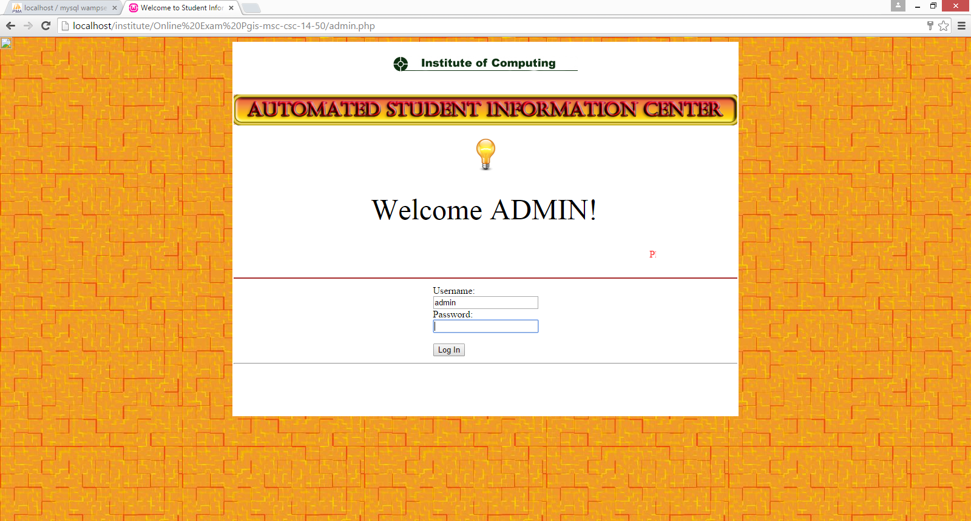

* Online Student Registration form

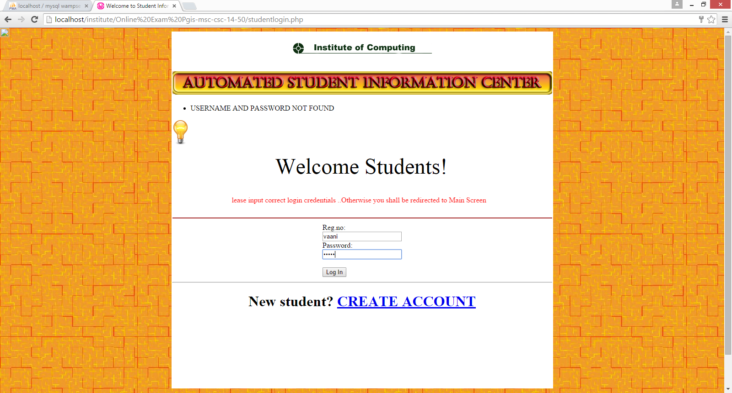

* Online examinations including MCQ and short answer questions

